Top of Form

ORDER FORM RYKA: AQUA SHOE – Instructor Shoe Program
125 Lilian Drive, Toronto  Ontario, Canada, M1R 3W6  Phone: 416-751-9823, Fax: 416-755-1832  Toll Free: 1-888-751-9823  E-mail:cala_aqua@mac.com Web: www.calainc.org |  |  |  |  |  |  |  |  |  |  |  |  |  |  |  |  |  |  |  |  |  |  |  |  |  | In order to ensure the integrity of this "instructor shoe program" offered by RYKA, please complete all sections of the form below and submit this form when placing your order. Your adherence to this request will keep the 'instructor shoe program' intact. |  |  |  |  |  |  |  |  |  |  |  |  |  |  |  |  |  |  | 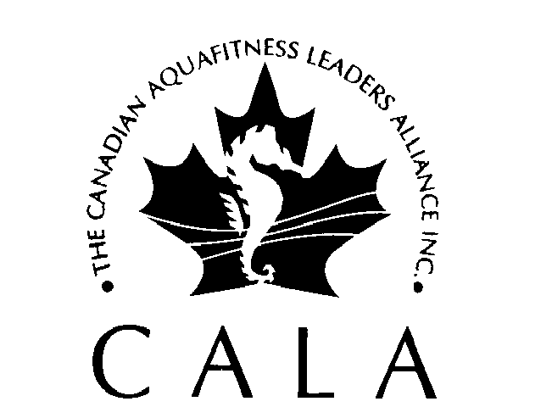
All information must be printed clearly in black ink or typed.
Please fax, email or mail the completed form to CALA. Please allow 2-3 weeks for delivery.

1. PURCHASER INFORMATION (required)
CALA Member Number |  |  |  |  |  |  |  |  |  |  |  |  |  |  |  |  |  |  |  |  |  |  |  |  |  |  |  |  | Date (mm/dd/yyyy)
Name: First |  |  |  |  |  |  |  |  |  |  |  |  |  |  |  |  |  |  |  |  |  |  |  |  |  |  |  |  | Last
Address |  |  |  | SHIPPING INFORMATION <INPUT TYPE=\SAME AS BILLING ADDRESS
City |  |  |  |  |  |  |  |  |  |  |  |  |  |  |  |  |  | Prov./State |  |  |  |  |  |  |  |  |  |  | Country |  |  |  |  |  |  |  |  |  |  |  |  |  |  | PC/Zip
Phone: Home |  |  |  |  |  |  |  |  |  | ( ) |  |  |  |  |  |  |  |  |  |  |  |  |  |  |  |  |  |  | Work |  |  |  |  |  | ( )
E-Mail |  |  |  |  |  |  |  |  |  |  |  |  |  |  |  |  |  |  |  |  |  |  |  |  |  |  |  |  | Fax |  |  |  |  |  | ( )
Facility Name |  |  |  |  |  |  | BILLING INFORMATION:

Address
City |  |  |  |  |  |  |  |  |  |  |  |  |  |  |  |  |  | Prov./State |  |  |  |  |  |  |  |  |  |  | Country |  |  |  |  |  |  |  |  |  |  |  |  |  |  | PC/Zip
Phone |  |  | ( ) |  |  |  |  |  |  |  |  |  |  |  |  |  |  |  |  |  |  |  |  |  |  |  |  |  | Fax |  |  |  |  |  |  | ( )

Supervisor Name
Certification (please check ✓) |  |  |  |  |  |  |  |  |  |  |  |  |  |  |  | ACE |  |  |  |  |  |  | CALA |  |  |  |  |  |  |  |  | OFC |  |  |  |  |  | YMCA |  |  |  |  |  |  |  | Other
2. SHOE INFORMATION (required) |  |  |  |  |  |  |  |  |  |  |  |  |  |  |  |  |  |  |  |  | Size |  |  |  |  |  |  |  |  | Ladies sizes only: 6 – 10 (half sizes available)
The shoes fits like a regular running shoe, and can be used in the water and on the deck. Generally, socks are not worn with the shoes. |  |  |  |  |  |  |  |  |  |  |  |  |  |  |  |  |  |  |  |  |  |  |  |  |  |  |  |  |  |  | <INPUT TYPE=\ Black/Silver <INPUT TYPE=\ Grey/Blue
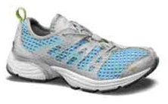 |  |  |  |  |  |  |  |  | Description: Specifically designed, hybrid water trainer engineered with a superior water drainage system, quick dry upper, proper cushioning and a molded support cage to keep you comfortable and moving. The perfect functional shoe for all your water sport needs.
Instructor Program: This program is designed for qualified and active aerobic/fitness instructors. Shoes are for personal use only. Our objective is to encourage instructors to experience our high performance products and allow current RYKA users to try new styles. We hope you will be convinced by our technology difference and recommend our shoes and RYKA Retailers.
Return/Exchange Policy: Please call CALA for return Policy and Procedure
3. METHOD OF PAYMENT (required) Prices subject to change without notice |  |  |  |  |  |  |  |  |  |  |  |  |  |  |  |  |  |  |  |  |  |  |  |  |  |  |  |  |  |  |  |  |  |  |  |  |  |  |  |  | CALA GST# 138567912
Price: CALA Member |  |  |  |  |  |  |  |  |  |  |  |  |  | $75.00CDN+$15.00(S&H)+tax |  |  |  |  |  |  |  |  |  |  |  |  | Non-CALA Member |  |  |  |  |  |  |  |  |  |  | $85.00CDN+$15.00(S&H)+tax
VISA |  |  |  |  | MC |  |  |  |  |  |  |  |  | # |  |  |  |  |  |  |  |  |  |  |  |  |  |  |  |  |  |  |  |  |  |  |  |  |  | Expiry Date
Name on Card |  |  |  |  |  |  |  |  |  |  |  |  |  |  |  |  |  |  |  |  |  |  |  | Authorized Signature
Purchase Order  Number |  |  |  |  |  |  |  |  |  |  |  |  |  |  |  |  | <INPUT TYPE=\Cheque Enclosed |  |  |  |  |  |  |  |  |  |  | Note: There will be a $50.00 penalty charge for NSF cheques and repayment must be by credit card or certified cheque/money order
CALA Office Use Only |  |  |  |  |  |  |  |  |  |  |  | Date Order Received at CALA |  |  |  |  |  |  |  |  |  |  |  |  |  |  |  |  |  |  |  |  | Invoice #
 |  |  |  |  |  |  |  |  |  |  |  | Order # |  |  |  |  |  |  |  |  |  |  |  |  |  |  |  |  |  |  |  |  | Date Order Shipped
Bottom of Form

