Sample Flyer

- Below is a sample Aquafit Brochure that you can modify and distribute to your current and new participants.
- You will need to add your facility specific information.
- Determine what should be included for your facility such as schedule, prices and bios of your instructors.
- Personalize the document by including pictures of your facility, your instructors etc.
- Modify according to your facility:
  - classes offered
  - bring to class
  - prepare for first class
  - allowed on deck and in pool
  - what to wear or not wear
  - other areas as required
- The document is landscape legal. You may want to modify to another format.
- If you are unable to print at your location consider taking the file on disc to a print shop such as Staples or Kinkos and have them print a copy.
- You should print it back to back and head to head and fold in half and then in half again.
- You can remove the “draft” watermark by going to the footer on the last page and deleting it..
Having a starting point will make it easier to create your own site specific brochure.
If you would like to share your brochure, please forward it in pdf format to CALA for inclusion on the CALA Handout webpage.
Contact your Aquatic Centre
Refer to the pool schedule for more details.
Your Logo
Centre Name
Address
City, Prov.
Phone: xxx-xxx-xxxx - Fax: xxx-xxx-xxxx
Web: www.xxxxxxx.ca
Aquatic contact: xxxxxxxxxxxxx
Available Aquafit classes
Aqua Walking
Improve balance, posture, walk and stability.
Aqua Deep
Perform non-impact exercises such as: drills, cycling, skiing and running-flotation belt worn.
Aqua Shallow
Perform gentle-impact exercises such as: drills, skiing, jump jacks, tucks and running.
Aqua Arthritis
Perform specific exercises that increase flexibility in joints and reduce arthritis pain
Aqua Prenatal
A water class designed for moms-to-be and new moms, training for the same thing: labor.
Schedule
Aqua Walking | T, Th - 9:30 am | 55+
Aqua Deep | W, F - 10:00 am | 19+
Aqua Shallow | M, W, F - 6:15 pm | 19+
Aqua Arthritis | T, F, - 4:00 pm | 19+
Aqua Prenatal | M, W, F - 1:00 am | Open
Orientation to Aquafit | 3rd Thurs of every month 6:30pm | Open
Prices
$8.00 per class adult $2.00 Senior
20 visit pass p/class $40 (not interchangeable)
Annual pass (access to all classes) $400
W  E  L  C  O  M  E  T  O  A  Q  U  A  F  I  T  N  e  s  s | 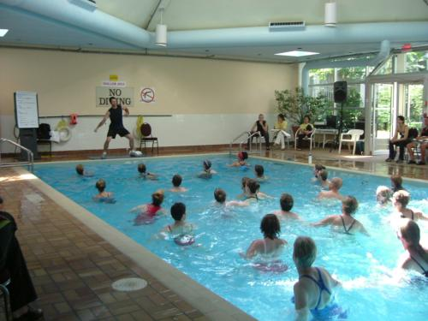  Aqua classes should not be mistaken as “easy”. Water is very suitable for all fitness levels, young and old. Whether you are coming back from an injury or are looking for an environment that surrounds you, literally, with resistance. No swimming skills are necessary for shallow class. Should be able to tread water for deep classes.  Benefits of Aquafitness  - Cardio-muscular training, gentle on the joints even under heavy strain!  - Stimulation of the joints' metabolism without strain  - High calorie consumption  - Strengthen, build-up and limber-up the muscular system - Train of all muscles  - Relieve on supporting muscular system  - Orthopaedically safe training  - Very short regeneration period  - Extremely low risk of injuries  Properties of Water  Buoyancy  Turbulence  Hydrostatic Pressure  Resistance  Thermal Connectivity

Magical properties of water
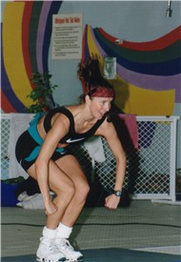
Through the use of the magical properties of water, the participants are able to challenge their nervous and respiratory systems. Through gaining control of their balance, agility, coordination and endurance, they are better able to be in control of their lives. Water resistance is the ideal work environment for strength-training. Using the water's resistance rather than equipment, the body receives an all over workout while working on isolated and/or corresponding muscles groups. The water's buoyancy reduces the joint impact.
Positive effects of resistance
- Accommodated by changing hand/foot configuration, lever lengths or speed of motion and intensity
- Multi-directional resistance
- Movements are slower and less jerky
Positive effects of buoyancy
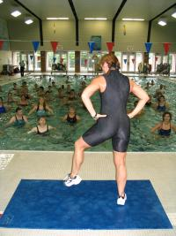
- Water decreases the amount of shock
- Decreases effect of gravity: body weight is reduced by 75% to 90% (chest to neck level immersion)
- Decreased gravity results in decreased joint loading
- The force of buoyancy assists venous return
- Lower exercise heart rates during aquafitness
Positive effects of hydrostatic pressure
- Assists participants to exercise more vigorously with less strain on the cardiovascular system
- Reduced training heart rate – heart rate is 10 bpm lower for a given workload
- Reduces swelling in injured or swollen joints or limbs below the water
- Pressure of water on chest wall creates a training effect for the respirator muscles
Positive effects of turbulence
- Currents and eddies in the water massage the skin, promoting circulation and relaxation
- Turbulence contributes to the resistance felt in aquatic exercise
- Core muscles strengthen as participants learn to stabilize their bodies against turbulence
- Exercises can be designed to work with or against turbulence
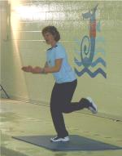
Positive effects of thermal conductivity
- Water 'wicks' away excess body heat creating a cool comfortable workout
- Blood that would be shunted to the skin for cooling is available to the working muscles
- The heart does not have to work as hard if the body stays cool
Shallow or Deep Aquafit?
Deep water class
- Non-impact. Perform suspended movements Wear a flotation belt – Must know how swim
- Use core strength – vertical, horizontal and 45^{O} angles movements
Shallow water class
- Low impact - Swimming skills not required
- Perform vertical; anchored, light bounce, propulsion, and suspended moves
Sample Aquafit movements
Some aqua movements include variations and combinations of:
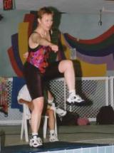
- Cross Country/Mogul Ski
- Cycling / Lunges / Walking / Jogging / Kicks / Marching
- Jumping Jack/Jill / Stretch / Dance / Tucks / Crunches
- Punch / Breast Stroke / Ski / Circle / Jack
Before coming to class
Medical
- Consult with your physician
- Complete required Participant Questionnaire
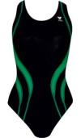
Swimwear
- Wear swimsuit with good support. (Your breasts need the same support as they do for land-based exercise.)
- 100% polyester swimwear lasts longer (Speedo/TYR). Bikinis have little to no support. Available at: Splashables 1-800-567-491-250 and Omni 1-800-461-3309
Care of swimwear
- Rinse in cold water immediately after use
- Rinse using solution that neutralizes chlorine
- Remove before using soap or shampoos
- Squeeze to remove water and lay to dry
Deciding on your class of choice
- Visit your facility, watch and/or take a class
- Consult with doctor to learn your needs
- Discuss class content with instructor
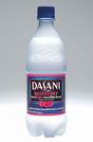
- Talk to other participants
Bring to class
- Required flotation or equipment
- Non-glass water bottle to prevent dehydration
- Leave at home all jewelry that may come off
- Water shoes/slippers to protect your feet
- Swimsuit, bathing cap, ear plugs, towel, lock
- Emergency medical history /information
- Your energy, enthusiasm and desire to exercise
Learn more about Aquafit
- Aquatic Exercise Therapy ISBN: 0721656811
- Aqua Fitness: ISBN: 078948949X
Important
Be prepared to get wet.
Aquafitness is exercising in water.
Upon arriving at your first class
- Arrive on time and take your place quickly
- Introduce yourself to the instructor
- Inform instructor of medical conditions including if you are pregnant
- Let instructor know if you have to leave early
- Deepwater classes – get flotation equipment
- Follow pool etiquette rules
- Remove gum and candies from your mouth
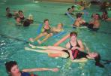
During class
- Drink water frequently
- Be prepared to get wet
- Work within your own limitations
- Pay close attention to your instructor’s safe leadership, cues and demonstrations
- Refrain from floating into people’s space
- Keep joints soft not locked when exercising
- Do only what feels right. If it hurts don’t do it
- Shallow water class – stand where the water is chest deep. Arms should remain in the water
- Converse, before or after class. Others are in class to exercise not listen to your conversation
- Refrain if doctor said not to do and exercise
- Respect your instructor and other participants. You are in a class not a free swim/Aquafit time
- Your kidneys will be working overtime due to hydrostatic pressure. You may need to leave the class to use the washroom. Don’t hold it!
How will you feel after your first class?
- Refreshed invigorated and energized
- Ready to take on the world
Leaving the class early
- Tell instructor, if you feel ill
- Leave quietly and without disrupting the class
Water has approximately 1000 times the resistance of air. Energy expenditure when doing aquafitness can achieve a workout intensity equal to or greater than on land
Cues your instructor may use
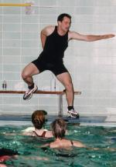
Your instructor will; ensure you work your total body, use various intensities and levels, and work within a safe range by providing you with verbal and nonverbal cues. Some clues are:
- Tempo, ½ temp or 2X’s tempo
- Hand, head and foot positions
- Working muscles group location
- Anchored (feet on floor), light bounce, propulsion (big bounce), and suspended
- Lever (leg and arm) length (short or long)
- Range of motion (full or partial) and direction
- Correct posture: tall back, tight abs and gluts, shoulders, chin, breath, drink water
Your instructor
- Is a trained and certified Aquafit professional
- Take ongoing training to remain current
- Will lead and coach you through a safe Aquafit class that will work all the major muscle groups and give you a total body workout
- Will demonstrate moves and educate you
- Will advise you of any pool/class issues
- Is not a medical professional and may not provide you with medical advice
Music
- Variety of music, 122-128 bpm is used
- Music motivates and enhances movements
- Volume may be loud – ear plugs help
Who benefits?
- Everyone – Families, all ages, body types and abilities, both sexes, languages, ethnicity
- Challenged people: weight, strength, stature mobility, health, vision
- Athletes, dancers, pre/post natal, fitness enthusiasts. health/ wellness conscious people
- Rehabilitation patients, cross training
How hard are you working?
Talk Test
The talk test is quite useful in determining your comfort zone of aerobic intensity.
Intensity | How you feel
10-8  Vigorous | Winded or too out of breath – may need to slow down
7-5  Moderate | Can carry on a conversation comfortably while exercising
4-1  Minimal | Able to sing while exercising. - May want to increase intensity
Rate of Perceived Exhaustion
Rate | How you feel
10-9 | So tired - I can’t Go Anymore
8-5 | Tired to Really Tired
4-1 | A little tired to not tired at all
Why people enjoy aquafitness?
- Relaxing, social, safe, gratifying and feels great
- Involves low to non-weight bearing exercises
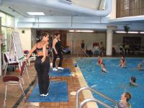
- Work hard but you don’t hurt after
- Motivating music
- Easy to stand in water
- Class participation
- People are great
- Able to work within own limitations
- Not embarrassing–everyone equal in the water
- Instructors are knowledgeable and care
How many classes can I take?
- One or two to start, increasing to your abilities
- Best time to exercise is in the morning. Your best time is what fits into your schedule.
- Alternate with another forms of exercise such as walking, swimming, cycling or yoga
- Consider taking a variety of Aquafit classes
- Consult with your physician

