Q: When exercising in water, I sometimes feel a pinch at my tailbone. What am I doing wrong?
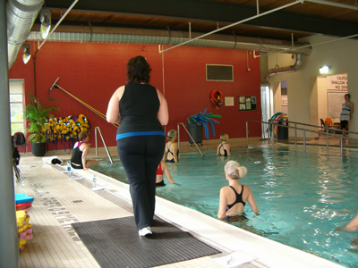
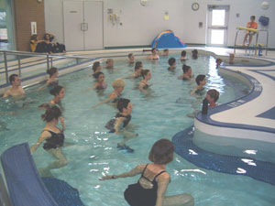
Acute pain may occur suddenly while exercising. Causes vary and depend on form, technique, fitness ability, muscular strength, any previous injuries to the specific area, etc. Pain could be mild to severe in intensity. In both land and water fitness, causes may include an abrupt offset of balance, misalignment of the spine, or unequal body weight bearing. Acute trauma may also result from excessive joint loading, ignoring any physical limitations or exceeding the appropriate range of motion at a particular joint. When exercising in an aquatic environment, it is important be aware of the forces generated while moving water. Water is more dense and heavier than air, thereby offering the potential for strong resistance. Balance, footing and stability are always challenged, as buoyancy, turbulence, and eddies (currents) all affect the body. Turbulence and currents generated by the movements of others nearby will also affect your stability. If you become off-balanced, stop the motion and re-adjust your form/stance. A sudden pinch or pain should NEVER be ignored. If you feel a sharp pain, pinch or stab, STOP immediately. (Feeling pain is very different from feeling physically uncomfortable or challenged!)

Proper posture is vital. Throughout a movement, maintain the spine and neck in neutral: long or “tall”. (Exception: In abdominal crunches, the spine is flexed, with the back, neck and shoulders slightly rounded and the chin slightly dropped. Any form of an ab crunch on land or a suspended ab crunch done in water should NEVER be performed with a straight spine or neck.) When standing while exercising, keep feet a minimum of hip-width apart for improved balance. In water, this safe stance is important in light bounce, propulsion or anchored movements.

Avoid an unreasonably wide stance as this will increase the demand and stress placed on the sacroiliac and lumbar zone of the back. Perform forward lean movements from the hip flexors to lessen the chance of lower back strain. By contrast, avoid excessively arching the lower back (hyper-extension). Similarly, perform posterior leg lifts with the hips in neutral and ‘gluteals’ activated. This awareness will limit the height of the leg lift and protect the low back as well.

Keep hips “squared” (horizontally equal, in neutral); and avoid slouching by maintaining and open posture, with scapula retracted and shoulders relaxed. Also, keep the knees “tracked” in line with the feet, never buckled in (hyper-extended), with the toes pointing forward. Meanwhile, avoid straight legs with “locked” knees (95% only for maximum extension). Maintain relaxed shoulders. Keep the shoulders “square” and positioned in line with the hips.

Activate the muscles of the inner unit, often referred to as the core: draw the navel gently towards the spine, without tilting the pelvis, this action will result in transverse abdominus activation. Also lift the pelvic floor (pubo-coccygeal muscles) by performing Kegel’s. Finally, connect the ribs and hips anteriorly, posteriorly and laterally with specific focus on activating the deep multifidus muscle in the low back region.

Do yourself a favour and look up these muscles on the internet to get a picture of where they are in your body!
Control all movements and keep them within a comfortable range of motion for each joint. Above all, listen to your body.

Contact: absfit@cogeco.ca OR: http://home.cogeco.ca/~absfit

